الاسم:عمر محمد محمود حسنين (2)
Chapter 7
Choices:
1) Which Python module is included in the standard library for working with SQLite databases (c)
2. What does conn.commit() do after an INSERT statement (b)
3. Which placeholder style is used in parameterized queries with sqlite3 (c)
4. Which method is used to fetch only the first row of a query result (c)
5. In SQLAlchemy, which class is commonly used to define ORM models (a)
True or false:
1. SQLite databases are stored in memory only and cannot be written to a file (False)
2. Using parameterized queries helps prevent SQL injection attacks (True)
3. The rollback() method can undo uncommitted changes in a transaction (True)
4. SQLAlchemy provides both Core (SQL Expression Language) and ORM interfaces (True)
5. cursor.execute() always returns a list of results (False)
Short answers:
- What is the difference between fetchone(), fetchmany(n), and fetchall() in database cursors?
Answer: • fetchone(): Returns the next single row.
• fetchmany(n): Returns the next n rows.
• fetchall(): Returns all remaining rows as a list.
- Why are parameterized queries preferred over string concatenation when inserting user input into SQL statements?
Answer: Because they prevent SQL Injection attacks (where hackers execute malicious SQL) and handle special characters automatically.
- What is a transaction in databases, and why is it important?
Answer: A transaction is a group of operations treated as a single unit (all succeed or all fail). It is important to ensure data integrity and consistency.
4. Write the steps (in order) to connect to an SQLite database and insert a row into a table.
Answer: 1. Connect: conn = sqlite3.connect('db.sqlite')
2. Cursor: cursor = conn.cursor()
3. Execute: cursor.execute("INSERT INTO ")
4. Commit: conn.commit()
5. Briefly explain how ORM (Object Relational Mapping) improves database handling in Python.
Answer: ORM allows us to work with Python Classes and Objects instead of writing raw SQL code. This makes the code cleaner, easier to read, and safer.

Problems:
Problem 1:
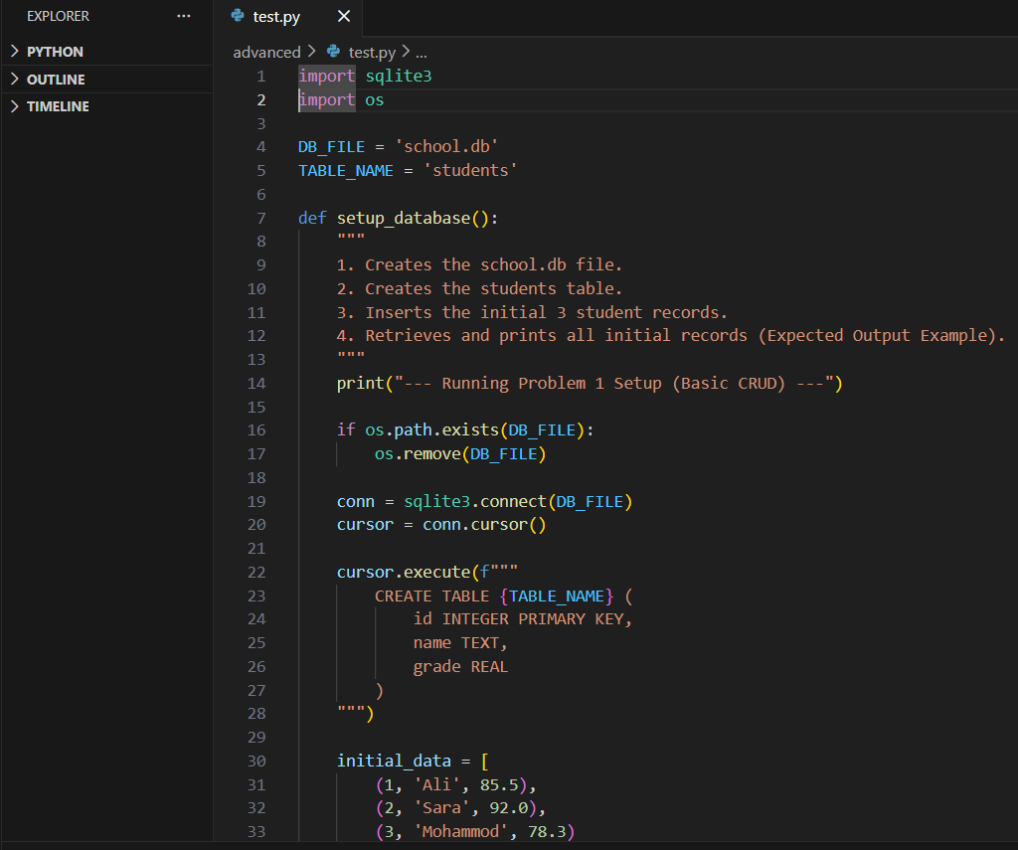
Problem 2: 